CALL FOR SUBMISSIONS:
Community engagement for inclusive rural transformation and gender equality
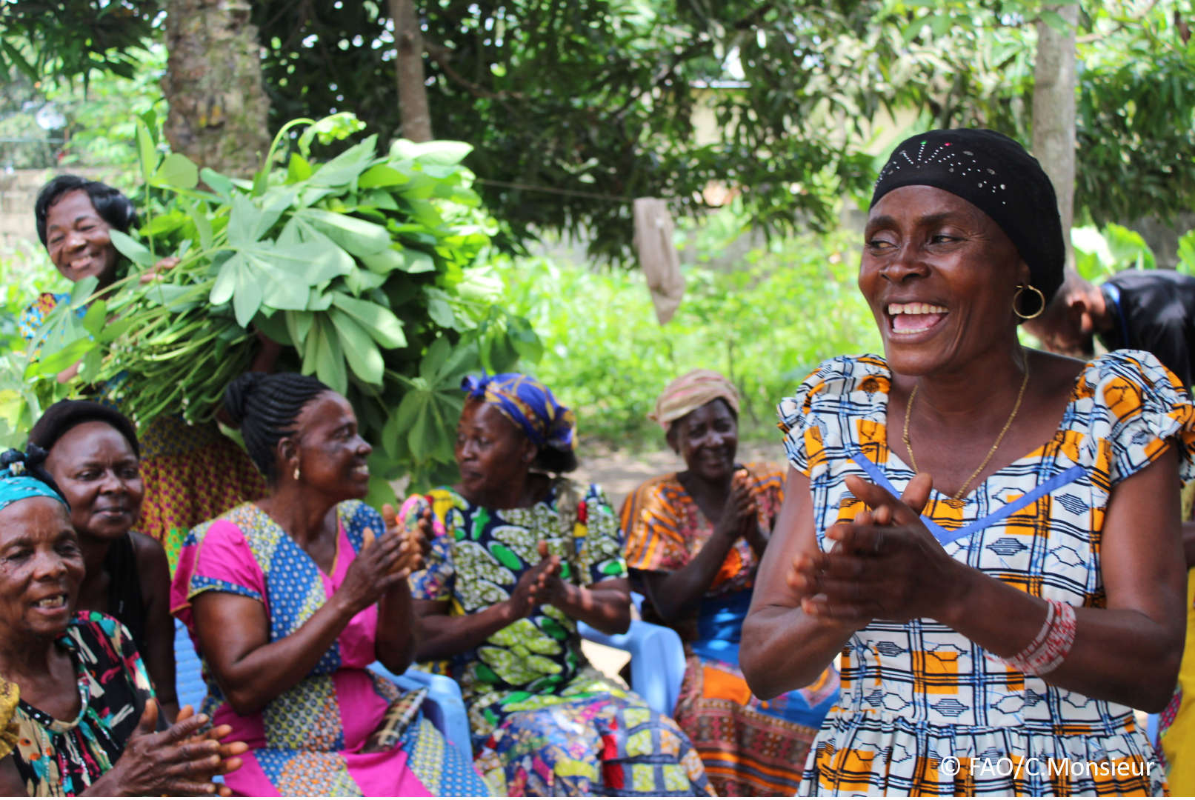
The objective of this call for submissions is to collect good practices, experiences, and lessons learned on the use of community engagement for inclusive rural transformation and gender equality. The initiative, organized by the Rural Transformation and Gender Equality Division (ESP), seeks to gather insights from a diverse range of contributors, both within FAO and from external stakeholders. Its goal is to share knowledge, foster learning, and guide the scaling up of community engagement and community-led collective action to leave no one behind. The call builds on FAO's past efforts in this area, such as the Community Engagement Days series of webinars.
The call for submissions is open until 27 November 2024.

How to take part in this call for submissions:
To take part in this Call for submissions, please register to the FSN Forum, if you are not yet a member, or “sign in” to your account. Please review the topic note to understand the criteria we are considering for this call. If you wish to learn more about community engagement, you may refer to the background document. Once you have completed this submission template, upload it in the box “Post your contribution” on the call webpage, or, alternatively, send it to fsn-moderator@fao.org.
Please keep the length of submissions limited to 1,500 words and feel also free to attach relevant supporting materials.

Template for submissions

Contact person | Name: Faith Adisa Musumba  Organization/Unit: CorpsAfrica  Country: Kenya  Email address: musumbafadisa@gmail.com
Name/title of the good practice | Community-Led Development through Volunteer Service
Where is the good practice taking place? (Multiple selection allowed) | ☐ Europe and Central Asia  ☐ Latin America and the Caribbean  ☐ North Africa and Near East  ☒ Sub-Saharan Africa  ☐ Asia and the Pacific  ☐ North America  ☐ Global
Affiliation | ☐ Farmer and producer organizations  ☐ Trade Union  ☐ Informal community-based, farmer-based or self-help group  ☐ Research and academia  ☐ Government  ☐ Local/traditional authorities  ☐ Private Sector  ☐ Civil Society Organization  ☐ Intergovernmental Organization (e.g. UN system, World Bank)  ☐ Resource Partner/Donor  ☒ Other (please specify)  Non-Governmental Organization
In which sector(s) and context (s) have you used this community engagement good practice? (Multiple selections allowed) | ☒ Education  ☒ Health and Sanitation  ☒ Food production in agrifood systems (please also tick the sub-categories)  ☐ Crop cultivation  ☐ Fisheries and aquaculture production  ☐ Livestock  ☒ Forestry  ☐ Agroforestry  ☒ Horticulture  ☒ Apiculture (beekeeping)  ☒ Agroecology and sustainable farming practices  ☐ Soil and water management  ☐ Other: ____________  ☒ Post-production in agrifood systems (please also tick the sub-categories)  ☒ Processing and value addition  ☐ Marketing and retailing  ☐ Transporting  ☒ Food loss and waste  ☒ Packaging  ☒ Storage  ☐ Distribution  ☐ Other _________  ☒ Gender Equality  ☒ Climate Action  ☐ Citizenship and Governance  ☒ Social Protection  ☒ Humanitarian and protracted crisis  ☒ Conflict resolution, peace and resilience  ☐ Digital innovation  ☐ Other sector (please specify) _________
Who are the financial partners supporting this good practice, if applicable? | Mastercard Foundation
- In a few sentences, summarize your community engagement good practice.
The local community members work together in a process of collective planning and action identify goals that are important to them, develop plans to achieve those goals, and implement those plans through using and building on the community's existing assets and strengths. The good practiced advocates for putting the community members at the center of their development by ensuring a human-centred design. The asset-based Community Development approach catalyzes the development and change by using the existing gifts and capabilities. The goal is to identify, activate, and connect the assets inside the community.
- What problem(s) or challenge(s) does your good practice aim to address through community engagement?
Capacity building and skills development- Empowering the community members with knowledge and skills that will enable the community members to be self-reliant in addressing their challenges.
Food security and malnutrition- Involve the community members in establishing kitchen gardens in the homesteads and school gardens to ensure the provision of nutrients to vulnerable populations such as children.
Community Ownership- Encouraging the importance of community-led initiatives that allow the community members to identify their needs, possible solutions, and the action to be taken. This fosters ownership and sustainable development.
Adaptation to climate variability- Working with the communities that face harsh climatic conditions to encourage them to plant drought-resistant crops, training, and climate-smart agriculture.
Economic Vulnerability- training the community members on sustainable agricultural practices that will ensure economic resilience through the growing of high-market value crops like cowpeas and green grams.

- Describe your good practice in more detail. Include the main guiding principles, the desired changes or outcomes you aim to achieve (Theory of Change), and the key phase implementation.
CorpsAfrica Kenya centers on community-led development. The practices emphasize on local community collaboratively designing and implementing solutions and challenges, taking ownership of their development, and building a sustainable practice. The main guiding principles include Participation and Inclusion: Directly involve people affected to develop and implement solutions in their communities and create an environment that encourages and supports the participation of all the people and different perspectives.
Focus on Assets Building Capacity: Identifying and developing the potential of people at the grassroots levels. Supporting efforts that lead to sustainable solutions emphasizing participation, partnership, and community economic development. Civic responsibility: Promote civic responsibility of residents in all aspects of the community. Encouraging psychological safety by encouraging individual and groups to freely express their views.
Collaboration and Partnership: Encourage collaboration and activities amongst the community. Embrace Diversity: Recognize differences among the community members and encourage inclusivity. Learn: Encouraging the environment that allows the community members to continually learn. Focus on Results: Encourage accountability and systems that allow information to be shared.
CorpsAfrica/Kenya theory of change.
Empowering communities through collaborative problem-solving, training, and participatory planning will help them develop sustainable solutions, that will address the challenges they face. This is because community ownership promotes accountability and effective use of resources.
Key Phase of Implementation.
CorpsAfrica Volunteers are deployed into the community and they integrate with the community members to build trust. The community collaboratively through community mapping and focus group discussion, identifies the community assets, needs, and possible solutions using the available community-based assets. The community members mobilize resources, establish partnerships, and use local resources to enable the implementation of the projects. The community members are trained on relevant for the projects such as; financial literacy and leadership. The project is then monitored through community feedback and relevant adjustment made based on emerging needs and community inputs.

- Who are the key actors and stakeholders involved in the design and implementation of the good practice, and what are their respective roles? Consider local partners, government, local authorities, community radios, civil society, research, the private sector, etc.

Community Members: They identify their needs, and possible solutions, contribute to knowledge, and manage the projects when the CorpsAfrica volunteers depart from the villages.
CorpsAfrica Volunteers: They are the catalysts, listeners, and facilitators. They live within the community and integrate freely will all the community members to ensure they understand community culture and dynamics.
Government Authorities: They make sure the projects align with the development plan and in other cases offer resources that will reinforce the projects.
Community-Based Organization and local NGOs: Collaborating with CorpsAfrica on different projects that goes in-hand with their area of focus.
Community Elders: They help in building trust between the community members and the CorpsAfrica Volunteer by endorsing the projects.
Educational Institution: They play a role in the school-based initiatives by helping to maintain the school gardens and educational initiatives.
Private Sector: Partner with CorpsAfrica to ensure the provision of raining such as financial literacy, in creating market linkages and resources.
CorpsAfrica Staffs: Offering support in training the volunteers, evaluating sustainable projects, and planning accordingly.
Donors: Provide technical and financial support and ensure effective utilization of community-led initiatives funds.

- How does your intervention ensure inclusivity and equal and meaningful participation within the community?
Describe how your intervention includes and engages different groups within the community. Consider aspects like gender, age, ethnicity, disability status, livelihoods, and other specific conditions (e.g., people living in prolonged crisis, migrants, refugees). Explain how your intervention engages diverse segments of the rural community. Highlight the specific actions or strategies you use to reach these groups. If applicable, mention if your intervention uses specific approaches such as gender-responsive, gender-transformative, intersectionality, or other methods to ensure inclusivity and gender equality.
The Volunteers engage various groups to hear out their priorities and concern. This is possible through the use of tools such as community mapping, focus group discussion, and group discussion. This ensures the active participation of every community member in identifying the community project that will be owned by them. The community makes decisions on how the project will be implemented and they can choose among them the committee members to govern each meeting. CorpsAfrica uses a model that can be adjusted based on the context of the community. The project fits within the community and all the community members can effectively participate. The volunteers involve the youths in leadership, financial, and practical training and skills. In addition, Junior CorpsAfrica created in school fosters the act of volunteerism and leadership among future generations. CorpsAfrica promotes gender equity and women empowerment by recognizing each gender as they play a role in community development. It allows feedback from the community through integration by allowing the adjustment of the project if necessary to ensure relevancy and inclusivity.
- By using community engagement, what results and impacts have your good practice achieved?
Please provide specific examples and evidence demonstrating the effectiveness of your intervention, focusing on both qualitative and quantitative outcomes related to livelihoods and well-being improvements.
Enhanced food security through advocating for kitchen gardens- CorpsAfrica has facilitated the establishment of over 1000 kitchen gardens. The initiative has enhanced the production of local vegetables thus improving the nutrition of the community members.
Women and Youth Empowerment program's inclusion of marginalized groups such as youths and women is very vital. CorpsAfrica has included this group to train them in modern farming techniques, post-harvest management, and climate-smart agriculture. Over 77% of the projects have benefited women and girls. Women have also shared stories of participating actively in decision-making within the community and being able to stand confidently.
Water and Sanitation Projects- CorpsAfrica has collaborated with the community to construct water catchment systems and irrigation systems that allow farmers and the general community to access water for human consumption and farming. Over 200 water projects have been constructed thus promoting water and sanitation. In addition, the partnership of community members and CorpsAfrica has enhanced the construction of toilets in schools.
- Among these results, has the good practice led to improvements in terms of gender equality, women’s empowerment, and/or social inclusion?
Describe the behavioral changes in terms of gender that good practice promotes, emphasizing agency, leadership, and participation in local governance. Include efforts to challenge discriminatory norms and unequal power dynamics. Highlight also how the intervention has supported the well-being (including psychological resilience) of marginalized groups and enhanced their inclusion and participation in decision-making processes.

Women empowerment- Women have been empowered through training and leadership opportunities offered by CorpsAfrica. This training has prioritized women enabling them to have skills in climate-smart agriculture, agricultural productivity, and effective management of resources. Women end up confidently leading training sessions and mentoring others in the community.
Gender Equality in Agriculture- Traditionally agricultural responsibilities have been divided with men and women taking different roles in Agriculture. CorpsAfrica encourages joint participation in the farming activities. Men and women collaborate to promote a more balanced workload. Men support women and they also participate in activities such as kitchen garden.
Shift in Community Attitudes and Gender Norms- Involving men in gender equality conversation, CorpsAfrica has encouraged support for marginalized groups and women. Data indicates that 77% of CorpsAfrica projects have benefited women and girls.
Youth Inclusion- CorpsAfrica has promoted skills-building programs that have given skills and increased self-reliance. The inclusion of people with disabilities has broadened social inclusion and increased acceptance within their communities. The Junior CorpsAfrica program has enhanced learning in primary and secondary school students. This program has promoted volunteerism among youths.
- What key challenges did you encounter while implementing the community engagement activities, and how did you address them?
Include any resistance from communities, pushback, or issues related to unequal power dynamics, if applicable.

Initial Resistance to Change- At the initial stage, some community members are not open to the CorpsAfrica Approach thus they hesitate to participate in new practices. CorpsAfrica uses volunteers who live in the community and integrate with the community members to build trust. The volunteers consistently communicate with the community members explaining CorpsAfrica's Mission, Vision, and aim. The volunteers emphasize that all the decisions will be led by community members.
Language Barriers -Language differences sometimes result in miscommunication during the projects and training implementation. The volunteers are encouraged to learn the community’s language. Additionally, local volunteer translators who understand the dialects are used to pass the information.
Financial Constraints- Financial constraints hinder many community members from participating in projects. CorpsAfrica encourages the use of assets-based community resources. CorpsAfrica welcomes partnerships with community-based Organizations and other local organizations allowing members to save and pool resources.
Water Scarcity- Water scarcity has been an obstacle in promoting community kitchen gardens and other food production. Water conservation techniques such as mulching, water pans, and other simple catchment systems have been introduced.

- What are the key lessons learned from your community engagement good practice?

Community engagement fosters ownership and is sustainable- Development led by community members allows the community members to set priorities promotes a sense of ownership and increases the project's sustainability. Through asset-based community mapping community members are allowed to be part of each part of the project.
Building Trust- The consistent presence of the volunteers in the community fosters trust. In the initial phase, community members are very hesitant about CorpsAfrica's intentions. Continuous spending time with the community and integrating with them creates a foundation for future collaboration and engagements.
Regular Feedback and Continuous Improvement- Community members' regular feedback helps in addressing challenges and providing valuable insights that improve projects. Regular feedback strengthens trust and continuous sustainable development.
Community engagement fosters gender and social inclusion- The inclusion of men, women, youths, and other marginalized groups fosters community resilience and improves social cohesion and sustainable growth and development.
Continuous Learning- Community members gain practical learning experiments. They take part in both theoretical and practical sessions. Reinforcing enthusiasm for the practices.
Community Engagement promotes partnering with Local leaders- Community leaders influence sustainable development. They are liaisons and they help encourage the acceptance of the practices.

- Has this practice been replicated in the same context or different contexts?
What are the required conditions to replicate and adapt the practice in another context/geographical area?
CorpsAfrica’s practices have been replicated in many communities in Kenya. The practices have been adopted in the same context to help address food security, education, and other community priorities. The practice has been done in semi-arid areas and in areas with limited infrastructures where community-led projects such as water harvesting and latrine constructions have been done. CorpsAfrica Practices have been replicated in different contexts. These practices have been adopted in Uganda, Malawi, Ghana, Rwanda and Senegal. The adaptation of the practice respects the local dynamics and maintains the principles and community ownership. The required conditions to replicate the practice include; Building trust by continuous engagement with the community members to understand the local culture and values, Training the facilitators on participatory tools such as community mapping and Participatory rural Appraisals, focusing on context-specific adaptation through assessing the culture, economic and local environments, Resource mobilization by training the community members to take ownership of the projects, Policy alignment through collaborating with the local governments and gain support thus avoiding duplication and continuous monitoring and evaluation to make improvements.
- How sustainable are the results achieved by this good practice?
Describe the key elements that need to be in place to make the initiative sustainable, including enabling environment (legal and policy frameworks and institutions), local ownership, accountability, etc.
The results are sustainable because of the emphasis on capacity building, and local ownership. The projects are managed by community members who ensure they are sustainable. The projects align with national and global priorities such as the Big Four Agenda, SDGs, Kenya Vision 2030, NGOs, local governance, and other supportive policies. The community owns the projects they identified through community mapping and they are trained in technical skills such as financial literacy. The Community-Led committees remain transparent and they oversee the project implementation and the community members provide feedback that governs the growth of the projects and ensures long-term effectiveness.

- Based on the conversations FAO held during the Community Engagement days, a definition of community engagement for empowerment was proposed:

“Community engagement for empowerment and community-led collective action can be defined as an inclusive and participatory process that enables community members to become active agents of change in decisions affecting their lives, health, and environment. This process develops their capacity to achieve sustainable outcomes for improved rural livelihoods. Embracing a rights-based approach, it prioritizes the agency and participation of all community members, regardless of gender identity, sexual orientation, age, ethnicity, caste, socioeconomic status, political affiliation, migration status, or ability/disability. Indeed, inclusive approaches recognize the complexities of overlapping marginalization and discrimination that can exclude different community members from decision-making processes and implement strategies to foster their participation, agency, and empowerment.”

We invite you to contribute to this definition. What would you add or change? Please share your thoughts, suggestions, and any additional elements you believe are crucial for a comprehensive understanding of community engagement approaches aimed at community-led collective action for inclusive rural transformation, people’s empowerment, and gender equality.

The definition is comprehensive. A few rationale suggestions to it include; transformative dimensions to ensure participation and systemic change, fostering collaborative community engagement, and addition of resilience and environmental stability to bring together aspects like food insecurity that result in the final development goals and acknowledgment of the overlapping marginalization.
- Based on your experience, what gaps or areas for improvement still need to be addressed in the field of community engagement?
Inclusivity of women, youths, and persons with disabilities remains a challenge as they often face barriers to actively participate.
Many initiatives are short-term as they lack mechanisms to sustain communities even after the project is completed.
A lack of capacity building can make a community not to effectively sustain a project after its completion.
The lack of well-designed monitoring and evaluation that involves community members hinders the success of the projects.
- What do you think is FAO's role in the field of community engagement? How can FAO support and enhance interventions like yours, if applicable? Consider aspects such as policy advocacy, capacity development, funding, technical assistance, knowledge production and sharing, and fostering partnerships.

FAO plays an important role in community engagement by providing expertise and resources to empower community members. FAO support can enhance initiatives like the ones CorpsAfrica implements by addressing gaps. FAO can work with the government to ensure participatory approaches in rural development and agriculture. Its capacity-building programs can help the communities and community volunteers strengthen their skills. FAO may not be direct donors but connecting community-led development with donors will help scale up successful initiatives and general social inclusion. FAO can help in fostering robust monitoring and evaluation by providing technical support for participation that enables the community members to provide feedback and track the project's progress.
Link(s) to specific references about your good practice (e.g. reports, communication products, videos, articles) | Please include attachment(s) or add here link(s) to documents/videos/podcasts/others with specific references.  CorpsAfrica/Kenya Project Demo Day 2024  https://www.youtube.com/watch?v=GJYtsBuqvSs  https://www.youtube.com/watch?v=WvckCQai3jI

The call for submissions is directly aligned with the thematic components of collective action within FAO's Programme Priority Areas (PPAs), specifically Better Life 1 (Gender Equality and Rural Women’s Empowerment), Better Life 2 (Inclusive Rural Transformation) and Better Life 3 (Agriculture and Food Emergencies).

